AI: ChatGPT
GPT Model: GPT-5.5

Scenario 1: File Upload

Weak Prompt: Generate test cases for file upload.

ChatGPT Response:
Test Case ID | Test Scenario | Test Steps | Test Data | Expected Result
TC_001 | Upload a valid file | 1. Open upload page 2. Select a valid file 3. Click Upload | document.pdf (allowed type, within size limit) | File uploads successfully
TC_002 | Upload multiple valid files | 1. Select multiple files 2. Click Upload | 3 valid files | All files upload successfully
TC_003 | Upload file using drag and drop | 1. Drag file into upload area 2. Drop file | Valid file | File is uploaded successfully
TC_004 | Cancel file selection before upload | 1. Select a file 2. Click cancel/remove | Any file | File is removed and upload is canceled
TC_005 | Replace selected file | 1. Select file A 2. Select file B | fileA.pdf, fileB.pdf | File B replaces file A
TC_006 | Upload without selecting a file | 1. Open upload page 2. Click Upload | No file | Validation message displayed
TC_007 | Upload file with unsupported extension | 1. Select unsupported file 2. Upload | .exe, .bat | Upload rejected with proper error message
TC_008 | Upload empty file | 1. Create empty file 2. Upload | 0 KB file | Upload rejected or handled based on requirements
TC_009 | Upload file exceeding maximum size | 1. Select large file 2. Upload | File > configured size limit | Upload fails with size error
TC_010 | Upload file at maximum allowed size | 1. Select file equal to limit 2. Upload | File = max size | Upload succeeds
TC_011 | Upload file just below maximum size | Upload file slightly smaller than limit | Valid large file | Upload succeeds
TC_012 | Upload file with special characters in filename | Upload file named test@#$%.pdf | Special-character filename | File handled correctly
TC_013 | Upload file with very long filename | Upload file with long name | Filename > allowed length | Proper validation displayed
TC_014 | Upload duplicate file | Upload same file twice | Same filename/content | System prevents duplicates or creates versions as expected
TC_015 | Upload file with uppercase extension | Upload .PDF instead of .pdf | REPORT.PDF | File accepted if extension is case-insensitive
TC_016 | Upload file with renamed extension | Rename .exe to .pdf and upload | Fake PDF file | File validation detects invalid content
TC_017 | Upload corrupted file | Upload damaged file | Corrupt PDF/image | Upload rejected or error shown
TC_018 | Upload file after session timeout | Login, wait for timeout, upload file | Valid file | User redirected or asked to re-authenticate
TC_019 | Refresh page during upload | Start upload and refresh | Large file | Upload behavior matches requirement
TC_020 | Close browser during upload | Start upload and close browser | Large file | Upload stops safely
TC_021 | Network interruption during upload | Disconnect network during upload | Valid file | Error shown and upload fails gracefully
TC_022 | Resume interrupted upload | Interrupt and restart upload | Large file | Upload resumes if supported
TC_023 | Verify upload progress indicator | Upload large file | Large file | Progress bar/status updates correctly
TC_024 | Verify uploaded file name | Upload file | test.pdf | Displayed filename matches original
TC_025 | Verify uploaded file download | Upload then download file | Valid file | Downloaded file matches uploaded file
TC_026 | Verify file storage location | Upload file and check backend | Valid file | File stored correctly
TC_027 | Upload same file from different users | User A uploads file, User B uploads same file | Same file | Access behavior follows permissions
TC_028 | Verify permission restrictions | Upload without required permission | Restricted user | Upload denied
TC_029 | Upload malicious file | Upload malware test file | EICAR test file | File blocked/quarantined
TC_030 | Verify virus scanning | Upload infected file | Virus sample | System detects and blocks file
TC_031 | Verify authentication requirement | Access upload URL without login | Unauthenticated user | Redirected to login
TC_032 | Verify HTTPS upload | Upload through application | Valid file | File transferred securely
TC_033 | Test concurrent uploads | Upload multiple files simultaneously | Multiple large files | System handles uploads correctly
TC_034 | Test upload performance | Upload large file under normal load | 500MB file | Upload completes within expected time
TC_035 | Test upload under high traffic | Multiple users upload files | Many concurrent users | System remains stable
TC_036 | Verify error messages | Trigger upload failures | Invalid files | Clear, user-friendly errors displayed
TC_037 | Verify file type filtering | Open file picker | Various file types | Only allowed types selectable
TC_038 | Verify mobile upload | Upload from mobile device | Image/document | Upload works correctly
TC_039 | Verify browser compatibility | Test Chrome, Firefox, Edge, Safari | Valid file | Upload works across supported browsers
TC_040 | Verify accessibility | Navigate upload using keyboard/screen reader | Valid file | Upload control is accessible
ICEPOT Prompt:
Context
Act as a Functional tester – Senior level and write test cases to test “File Upload” functionality in an insurance page, which will be displayed after the login page. 70% of weightage should be given to functional test cases and remaining 30% to security test cases. Count of test cases should be 10-12.
Instruction
[MANDATORY] Generate testcases for validating the functionality with supported file types – JPEG and PNG
[MANDATORY] Generate testcases for validating the functionality with maximum size limit of 5 MB
[MANDATORY] Generate testcases for validating the functionality with success toast message after uploading the file successfully
[MANDATORY] Generate testcases for validating the functionality with failure toast message when there is error during the upload
[CRITICAL] Include testcases for validating the security aspects – The UI should prevent the file from fully uploading (e.g., stopping at 99%)
[HIGH PRIORITY] Generate test cases to verify a clear, user-friendly error is displayed (e.g., "The file could not be processed. Please upload a different file."). Error message should not include technical jargon or revealing that a virus detected, as this can give hackers insight into security attack
[LOW PRIORITY] Generate testcases for validating the file name length and typography
[LOW PRIORITY] Generate testcases for validating the styling and alignment of page
[HIGH PRIORITY] Generate test case for validating the file upload using drag and drop
[HIGH PRIORITY] Generate test case for validating the file upload by replacing the already uploaded file
[STRICT] Generate test case for validating the functionality through chrome browser and windows OS
Example:
TCID | Description |Priority|Preconditions| Steps |Expected Result
Persona
Act as a Peer to review the testcases
Output
Downloadable excel file
Tone:
Generate the test cases in a way it should be presented to Business/ Higher management for demonstration purposes
ChatGPT Response:
I have created the Excel file containing 12 senior-level functional and security test cases for the Insurance File Upload functionality.
The test cases are structured for Business / Higher Management demonstration and include:
- ✅ 70% focus on functional validation
- ✅ 30% focus on security validation
- ✅ Supported file types: JPEG and PNG
- ✅ Maximum file size validation: 5 MB
- ✅ Success toast message validation
- ✅ Failure toast message validation
- ✅ Security validation for upload prevention (e.g., stopping before completion)
- ✅ User-friendly security error message validation
- ✅ Drag-and-drop upload validation
- ✅ Replace existing uploaded file validation
- ✅ Filename length and typography validation
- ✅ Page styling/alignment validation
- ✅ Chrome browser + Windows OS validation
You can download the Excel file here:
Downloaded File Screenshot:
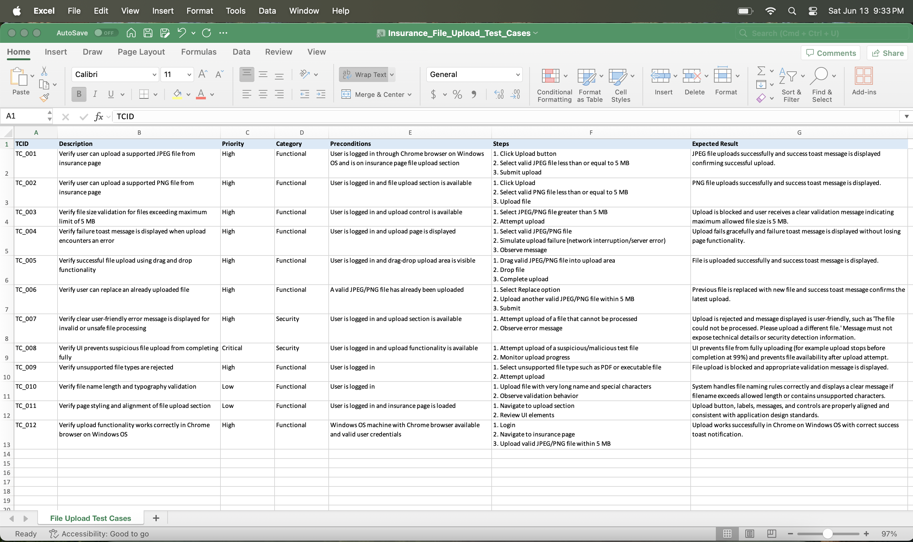
*************************************************************************
Observation:
- Given 10-12 as the test case count, the test cases were generated with the maximum number in the range (12 test cases).
- Even though the Category column was not specifically mentioned in the Examples section, based on other requirements, the Category column was added to the generated Excel file.
- When the requirement/user need is precisely given, it makes the job easier for the AI model and reduces repeated prompting/user input.
*************************************************************************
Scenario 2: Shopping Cart

Weak Prompt: Test the cart functionality.

ChatGPT Response:
I’ll approach this as a Senior Functional Tester and provide test cases for an e-commerce Cart functionality. The focus is primarily functional testing, with some security coverage.

Test Case ID | Test Scenario | Test Steps | Test Data | Expected Result | Type
TC_CART_001 | Add a product to cart | 1. Login to application2. Navigate to product page3. Click "Add to Cart" | Valid product | Product should be added successfully and cart count should update | Functional
TC_CART_002 | Verify cart details | 1. Add product to cart2. Open cart page | Product with name, price, quantity | Cart should display correct product details, price, image, and quantity | Functional
TC_CART_003 | Add multiple products to cart | 1. Add different products2. Navigate to cart | Product A, Product B | All selected products should appear in cart | Functional
TC_CART_004 | Update product quantity in cart | 1. Add product2. Change quantity using +/− option or input field | Quantity: 2 | Cart quantity should update and total price should recalculate correctly | Functional
TC_CART_005 | Remove product from cart | 1. Add product2. Click Remove/Delete option | Existing cart item | Product should be removed and cart total should update | Functional
TC_CART_006 | Verify cart persistence after logout/login | 1. Add items to cart2. Logout3. Login again | Registered user account | Cart items should persist according to application requirements | Functional
TC_CART_007 | Verify cart behavior for guest user | 1. Browse without login2. Add product to cart3. Close and reopen browser | Guest user | Cart should behave according to guest cart policy (retain or clear items) | Functional
TC_CART_008 | Verify maximum quantity limit | 1. Add product2. Increase quantity beyond allowed limit | Quantity exceeding stock | System should prevent invalid quantity and show appropriate message | Functional
TC_CART_009 | Verify out-of-stock product handling | 1. Add product with limited inventory2. Change quantity beyond available stock | Stock = 0 or limited | User should receive stock availability message and checkout should be restricted | Functional
TC_CART_010 | Verify cart total calculation | 1. Add multiple products2. Apply quantity changes3. Check total | Multiple products with different prices | Subtotal, tax, discounts, and final total should calculate correctly | Functional
TC_CART_011 | Validate unauthorized cart access | 1. Copy cart URL2. Open in another browser/session without authentication | Invalid session | Application should enforce access rules based on design | Security
TC_CART_012 | Validate cart input security | 1. Modify quantity parameter/request payload2. Send malicious input | Script/SQL payload | Application should reject malicious input and sanitize data | Security
ICEPOT Prompt:
Context
Act as an end user and write test cases to test the “Shopping Cart” functionality of a retail application. The component is to be manually validated for functionality. Count of test cases should be 12-15.

Instruction

[CRITICAL] Generate test cases to validate that adding an item to the shopping cart is allowed for guest, newly signed-up, and signed-in users.
[MANDATORY] Generate test cases to validate the functionality for updating the shopping cart by editing item quantities.
[MANDATORY] Generate test cases to validate the functionality for updating the shopping cart by adding more items.
[MANDATORY] Generate test cases to validate the functionality for deleting items from the shopping cart.
[MANDATORY] Generate test cases to validate that the shopping cart displays the consolidated price total of all available items.
[HIGH PRIORITY] Generate test cases to validate that the shopping cart's consolidated price total excludes tax calculations.
[HIGH PRIORITY] Generate test cases to validate that the shopping cart's consolidated count is updated based on the Add/Update/Delete scenarios.
[MANDATORY] Generate test cases to validate the shopping cart's discount/coupon section by providing valid and invalid (expired/already used) coupons.
[HIGH PRIORITY] Generate test cases to validate the shopping cart by applying multiple discount coupons. It should allow the user to utilize more than one valid coupon at a time.
[MEDIUM PRIORITY] Generate test cases to validate the shopping cart display order. The most recently added items should be displayed at the top.
[LOW PRIORITY] Generate test cases to validate the styling and alignment of the page.
[HIGH PRIORITY] Generate test cases to validate the shopping cart's ability to "Save for Later" any added items.
[MANDATORY] Generate a test case to validate the shopping cart when it contains "Out of Stock" items. A message should appear below the item in a red font stating "Item went out of stock," and updating the quantity should be disabled.
[MANDATORY] Generate a test case to validate that a user cannot place an order if there are "Out of Stock" items in the cart.
[STRICT] Generate test cases to validate functionality across the Chrome browser on Windows OS, as well as on the iOS mobile app.

Example:
TCID | Description |Priority|Preconditions| Steps |Expected Result

Persona
Act as a Business Person to review the testcases

Output
Downloadable excel file. “All Border” to be applied for the content within generated file.

Tone:
Generate the test cases so they are reusable for similar applications.

ChatGPT Response:
I have created the reusable Shopping Cart functional test cases workbook in Excel format. The file includes:
- 14 test cases covering all requested scenarios
- Priority classification
- Preconditions
- Manual execution steps
- Expected results
- Coverage for:
  - Guest, newly signed-up, and signed-in users
  - Add/update/delete cart operations
  - Quantity changes
  - Price total and tax exclusion
  - Cart count updates
  - Coupon validation (valid, expired, used)
  - Multiple coupon application
  - Display order
  - Save for Later
  - Out-of-stock handling
  - Order prevention for out-of-stock items
  - Chrome on Windows and iOS mobile app validation
  - UI styling/alignment checks
- All cells have borders applied as requested.
Download the Excel file here:
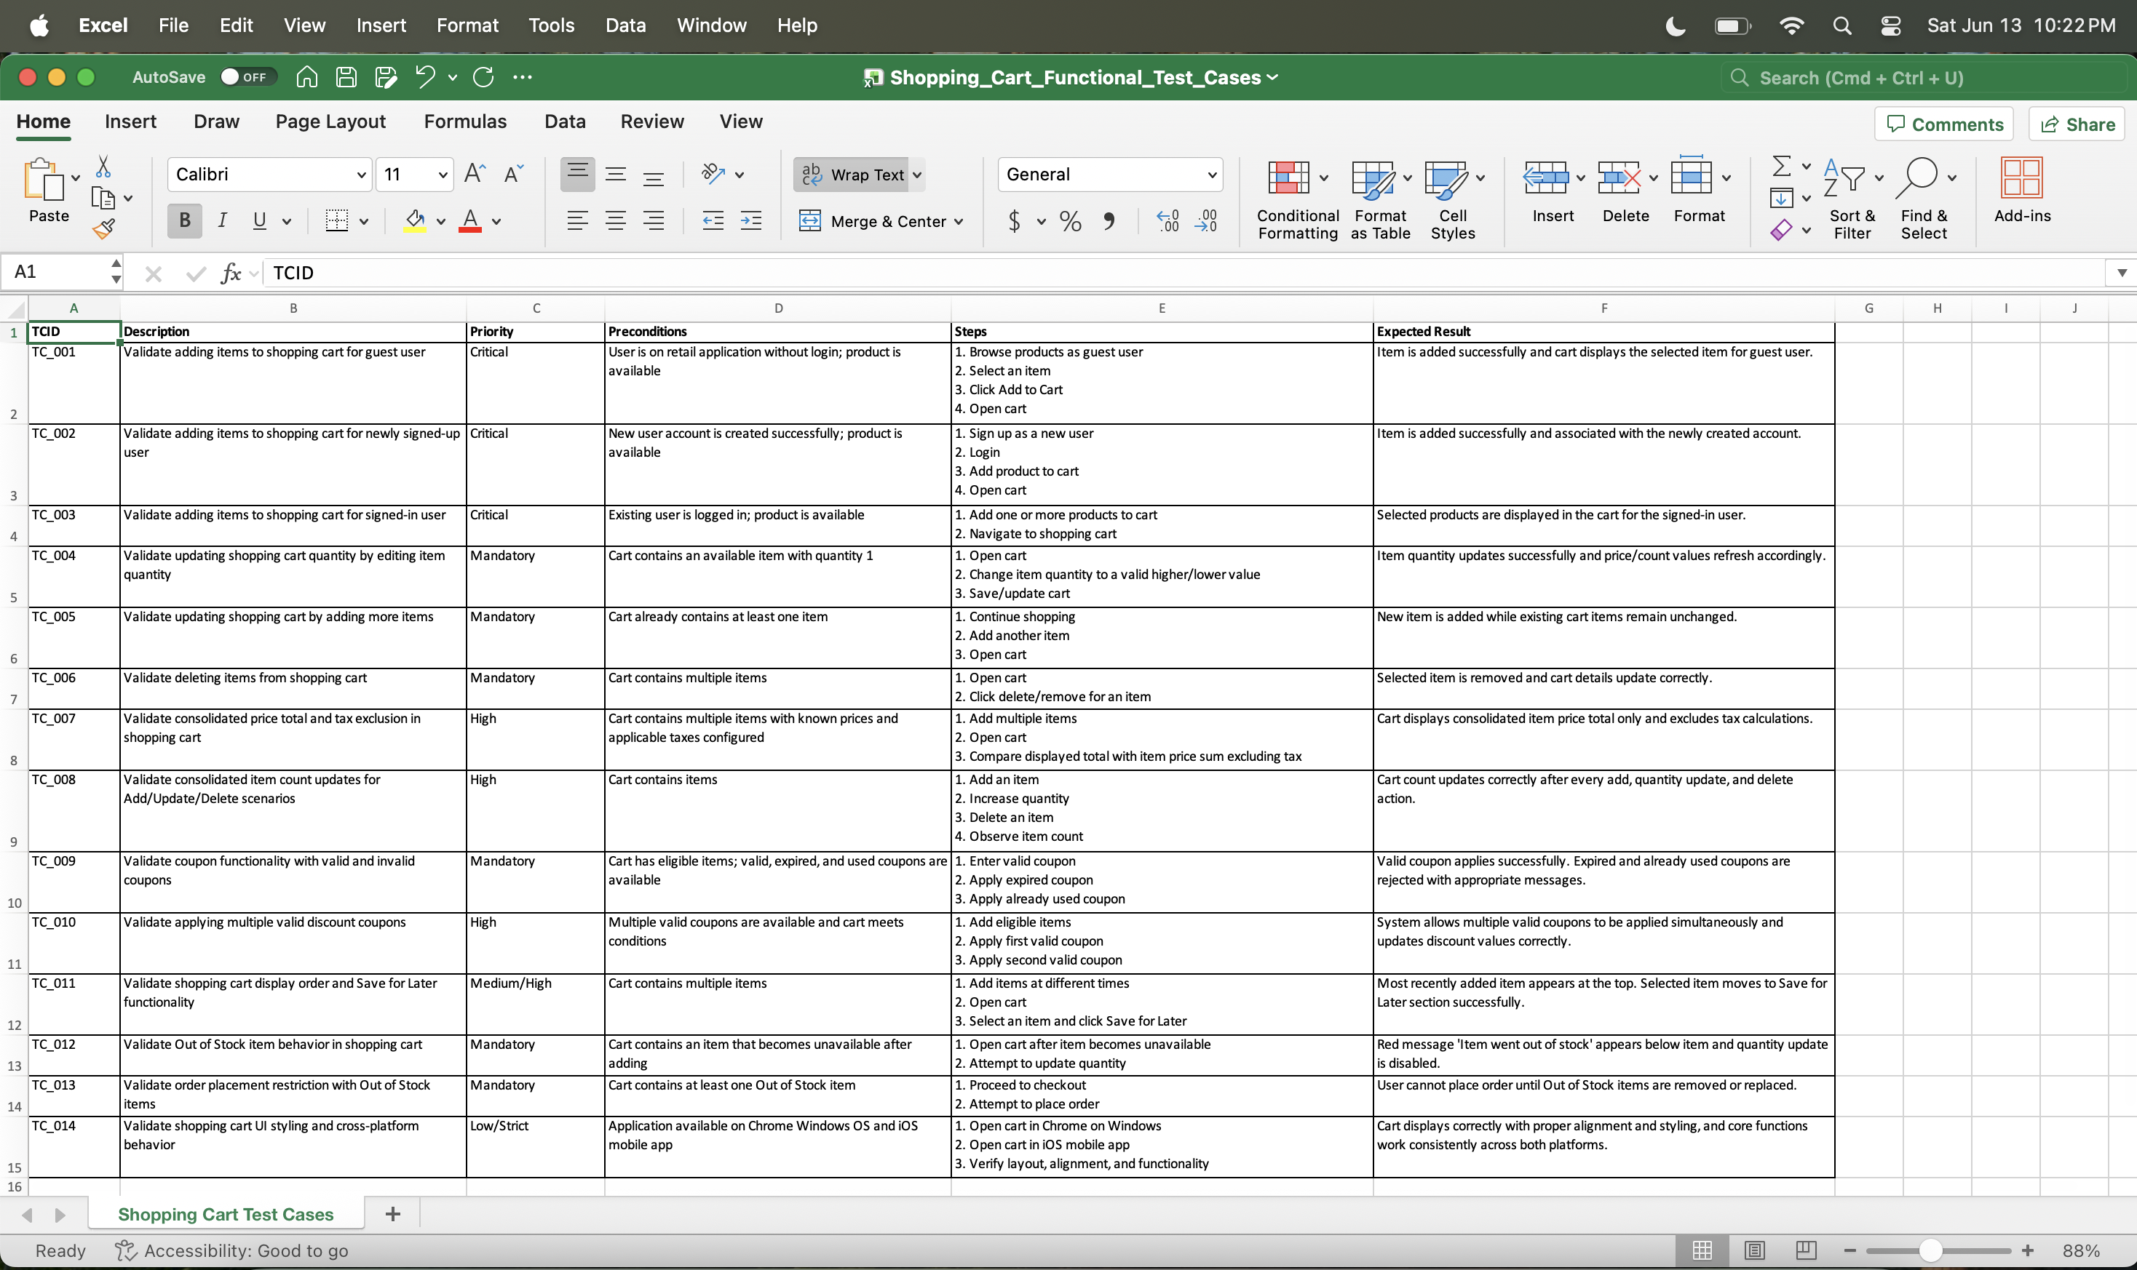
*************************************************************************
Observation:
- Even though a new chat was created, it carried forward the user role, test case count, and other requirements to generate the current prompt response.
- Low and strict priority test cases were combined, even though they could have been split into individual test cases. This was done even though there was room for one more test case within the provided range (Given range: 12-15; generated count: 14).
- Beyond just the content, I can also design the format of the generated file. (For example, I requested a border/outline for the file, and it worked as expected).
- It did not consider the provided persona.
*************************************************************************
Scenario 3: API Testing

Weak Prompt: Write API test cases for user registration.

ChatGPT Response:

API Endpoint Example: POST /api/v1/users/register
Purpose: Validate user registration API functionality, input validation, security, and error handling.
Test Case ID | Test Scenario | Test Data / Request | Expected Result
API_REG_001 | Verify user registration with valid details | Valid name, unique email, valid password, required fields | API should return 201 Created. User account should be created successfully.
API_REG_002 | Verify registration with already registered email | Existing email address with valid user details | API should return 409 Conflict (or configured error code). Response should indicate email already exists.
API_REG_003 | Verify registration without mandatory fields | Missing email/password/name fields | API should return 400 Bad Request with validation error details.
API_REG_004 | Verify registration with invalid email format | "user@com" or "user.com" | API should reject request and return 400 Bad Request with email validation message.
API_REG_005 | Verify registration with weak password | Password below minimum length or without required complexity | API should reject request with password policy validation error.
API_REG_006 | Verify registration with password exceeding maximum length | Password length greater than allowed limit | API should return validation error indicating maximum length exceeded.
API_REG_007 | Verify registration with empty/null values | Name/email/password sent as empty or null | API should return 400 Bad Request with appropriate field-level errors.
API_REG_008 | Verify registration with special characters in input fields | Name containing unsupported characters or malicious input | API should validate input and prevent invalid data storage.
API_REG_009 | Verify SQL injection prevention during registration | Email/name containing SQL payload (' OR 1=1 --) | API should safely reject/handle input without database impact.
API_REG_010 | Verify XSS attack prevention during registration | Name field containing <script>alert(1)</script> | API should sanitize input and prevent script execution/storage.
API_REG_011 | Verify duplicate registration request handling | Send same registration request multiple times | API should create only one account and handle duplicate requests gracefully.
API_REG_012 | Verify response schema after successful registration | Valid registration request | Response should contain expected fields (user ID, message, timestamp) and should not expose sensitive data.
API_REG_013 | Verify password is not returned in API response | Valid registration request | Response should not contain password or sensitive authentication details.
API_REG_014 | Verify authentication token generation after registration (if applicable) | Successful registration | API should return valid access/verification token based on requirement.
API_REG_015 | Verify registration API without authentication headers | Registration request without required headers (if applicable) | API should return appropriate authorization error.
API_REG_016 | Verify unsupported HTTP methods | Send GET/PUT/DELETE request to registration endpoint | API should return 405 Method Not Allowed.
API_REG_017 | Verify incorrect Content-Type header handling | Send request with text/plain instead of application/json | API should reject request with unsupported media type error.
API_REG_018 | Verify registration with maximum allowed field lengths | Name/email/password at boundary length | API should successfully process valid boundary values.
API_REG_019 | Verify registration API response time | Submit valid registration request under normal load | API response should be within defined SLA.
API_REG_020 | Verify concurrent registration attempts with same email | Multiple simultaneous requests using same email | Only one user should be created; other requests should receive duplicate user error.

ICEPOT Prompt:
Context
Act as an API tester and write test cases to test the “User Registration” functionality of a Healthcare application. The component is to be validated through automation testing.

Instruction

[CRITICAL] Generate test cases to validate “User Registration” API through postman – JS programming language

[MANDATORY] Generate test cases to validate “User Registration” API through HTTP method as “POST”

[MANDATORY] Generate test cases to validate “User Registration” API with endpoint as v1/user/register

[HIGH PRIORITY] Generate test cases to validate “User Registration” endpoint with different environments (QA, STG)

[MANDATORY] Generate test cases to validate “User Registration” API with mandatory request header “Key: Content-Type ; Value: application/json”

[MANDATORY] Generate test cases to validate “User Registration” API requiring an API Key in the header to allow registration

[HIGH PRIORITY] Generate test cases to validate “User Registration” API response status code with a 400 Bad Request if required fields are missing or improperly formatted (e.g., weak password, invalid email structure

[HIGH PRIORITY] Generate test cases to validate “User Registration” API response status code with a 201 Created and a JSON response containing confirmation details (e.g., a unique id, message, or generated token)

[HIGH PRIORITY] Generate test cases to validate “User Registration” API response status code with a 409 Conflict or 400 Bad Request status code if the username or email is already registered.

[LOW PRIORITY] Generate test cases to validate “User Registration” API by providing not properly formatted request (Eg: missing semicolons)

[MEDIUM PRIORITY] Generate test cases to validate “User Registration” API providing backend trims accidental leading or trailing spaces from text inputs instead of saving them into the database

Example:

Request Payload:
{
"username": "testuser123",
"email": "testuser123@example.com",
"password": "SecurePassword123!",
"fullName": "John Doe"
}

Test Scripts:
// Validate successful registration code
pm.test("Status code is 201", function () {
pm.response.to.have.status(201);
});

// Verify response body returns an ID or success message
pm.test("Response contains user ID", function () {
var jsonData = pm.response.json();
pm.expect(jsonData).to.have.property('id');
});

Success Response:
{
"status": "success",
"message": "User registered successfully.",
"data": {
"id": "usr_9f82b3c1a7d4e5f6",
"username": "testuser123",
"email": "testuser123@example.com",
"fullName": "John Doe",
"createdAt": "2026-06-13T22:46:00Z"
},
"token": "eyJhbGciOiJIUzI1NiIsInR5cCI6IkpXVCJ9..."
}

Persona
Act as an API Test lead to review the code

Output
Downloadable file supported by postman.

Tone:
Generate the code to be easily understandable

ChatGPT Response:
I created a Postman Collection JSON file for the Healthcare User Registration API automation testing.
The collection includes:
- ✅ HTTP method validation: POST
- ✅ Endpoint validation: v1/user/register
- ✅ Environment variable support (QA/STG via baseUrl variable)
- ✅ Mandatory header validation:
  - Content-Type: application/json
  - API Key header (x-api-key)
- ✅ Positive test:
  - 201 Created
  - Response JSON validation
  - Unique user ID validation
  - Token validation
- ✅ Negative tests:
  - Missing mandatory fields → 400 Bad Request
  - Invalid email / weak password → 400 Bad Request
  - Duplicate username/email → 409 Conflict or 400 Bad Request
  - Missing API Key → 401/403
  - Invalid JSON payload format
- ✅ Input trimming validation using Postman JavaScript assertions
You can import the collection directly into Postman:
For execution:
- Import the JSON file into Postman.
- Create QA and STG environments.
- Update:
  - {{baseUrl}}
  - {{apiKey}}
- Run the collection using Collection Runner/Newman for automation execution.
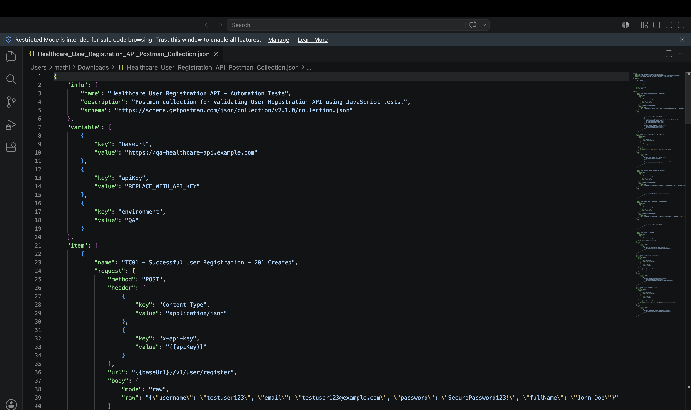

*************************************************************************
Observation:
- Generated JSON file without explicitly mentioned
- Did additional tasks like creating baseURL variable to support different environment execution
- Not sure about tracking the Priority provided
*************************************************************************

